**Contextual Text Extraction from PDF files Using Machine Learning Practices**

CAPSTONE PROJECT REPORT

By

Team 03

A Harshith 21R11A0504

P Rohith 21R11A0537

G Harshit 21R11A0519

G Pranav 21R11A0515

D Nissi 21R11A0511



**Department of Computer Science and Engineering**

**Accredited by NBA**

**Geethanjali College of Engineering and Technology**

**(UGC Autonomous)**

(Affiliated to J.N.T.U.H, Approved by AICTE, New Delhi)

Cheeryal (V), Keesara (M), Medchal.Dist.-501 301

March 2024

**ABSTRACT**

The abstract outlines the core essence of the project, highlighting its purpose, methodology, and expected outcomes. In this project, we aim to develop a web application facilitating the automated extraction of director details from PDF documents, responding to the growing need for efficient corporate governance and regulatory compliance. By leveraging Flask, a lightweight Python web framework, and pdfplumber, a PDF processing library, the application provides an intuitive interface for users to upload PDF files containing director appointment information. Once uploaded, the application extracts text from these files and applies regular expressions to identify and extract key director details, such as names, DINs (Director Identification Numbers), and roles. The extracted information is then presented to users in a structured format on a results page, enhancing accessibility and usability. This project aligns with the modernization trend in corporate management, offering a solution that optimizes the extraction and management of director information, ultimately contributing to improved transparency and compliance within organizations. Through this initiative, we anticipate a significant reduction in manual effort and error, as well as enhanced accuracy and efficiency in director information management processes. **TABLE OF CONTENTS**

|  |  |  |
| --- | --- | --- |
| **S No** | **Title** | **Page No** |
|  | **ABSTRACT** | 2 |
| **1** | **INTRODUCTION** | 4 |
| **2** | **PROBLEM STATEMENT** | 5 |
| **3** | **OBJECTIVES** | 5 |
|  | 3.1 Existing Methods | 6 |
|  | 3.2 proposed Methods | 7 |
| **4** | **METHODOLOGY** | 8 |
|  | 4.1 Data Source | 8 |
|  | 4.2 Text Extraction | 9 |
| **5** | **Final Implementation** | 10 |
| **6** | **Conclusion & Future Scope** | 13 |

1. **INTRODUCTION**

The introduction provides context and rationale for the project, focusing on the significance of accurately managing director details in the corporate landscape. In contemporary business environments, effective governance and adherence to regulatory standards are paramount for organizational success and stakeholder trust. A crucial aspect of corporate governance involves the proper documentation and management of director information, including their names, roles, and unique identifiers such as the Director Identification Number (DIN).

As companies evolve and grow, they frequently appoint new directors or modify existing roles, necessitating a streamlined process for updating and managing director details. Traditional methods of manual data extraction from official documents, such as appointment letters and resolutions, are often laborious, error-prone, and time-consuming. Moreover, the complexity and diversity of document formats present additional challenges in extracting relevant information accurately.

This project addresses these challenges by developing a web-based tool that automates the extraction of director details from PDF documents. Leveraging modern technologies such as the Flask web framework and the pdfplumber library, the application offers a user-friendly interface for uploading PDF files containing director appointment information. Upon upload, the application employs advanced text extraction techniques to identify and extract key director details, including names, DINs, and roles. Regular expressions are utilized to parse through the extracted text, enabling the identification of specific patterns indicative of director information.

By providing a systematic and efficient solution for extracting director details from PDF documents, this project aims to enhance corporate governance practices and regulatory compliance. Organizations stand to benefit from increased transparency, accuracy, and efficiency in managing director information, thereby fostering trust among stakeholders and mitigating compliance risks. Furthermore, the automation of this process reduces manual effort and minimizes the likelihood of errors, contributing to overall operational efficiency and effectiveness within organizations.

**2. PROBLEM STATEMENT**

Extracting specific data from unstructured documents like reports, surveys, or social media posts is a hurdle across many fields. Manual processing is slow, inaccurate, and unmanageable for large volumes. The unstructured nature of these documents, with varying formats and lack of standardized layout, makes it difficult to efficiently extract crucial information. This inefficiency hinders tasks like market research, customer analysis, and literature reviews, demanding a more automated and reliable solution.

**3. OBJECTIVES**

The primary goal of this capstone project revolves around the development of an automated solution leveraging machine learning methodologies to effectively extract critical data from PDF documents. With precision at its core, the project targets the extraction of key information such as Director Names, their classification as Independent or Executive, and their associated DIN. Ensuring robustness, accuracy, and scalability are paramount objectives, empowering the solution to adeptly handle diverse PDF document structures and formats with ease.

**3.1 Existing Methods:**

1. Manual Extraction: This traditional method involves manually reading through PDF documents containing director appointment information and extracting relevant details such as names, roles, and DINs. While accurate, this approach is time-consuming and labor-intensive, making it impractical for large volumes of documents.

2. Text-Based Parsing: Some solutions utilize text parsing techniques to extract information from PDF documents. This involves programmatically analyzing the text content of PDF files and applying rules or patterns to identify director details. While more efficient than manual extraction, text-based parsing methods may struggle with complex document structures and formatting variations.

3. Optical Character Recognition (OCR): OCR technology converts scanned PDF documents into editable text, allowing for automated extraction of director details. OCR-based solutions can be effective in handling scanned documents, but accuracy may vary depending on the quality of the scan and the clarity of the text.

4. Machine Learning: Advanced techniques such as machine learning can be employed to train models to recognize and extract director details from PDF documents. These models learn patterns and structures from labeled data and can improve accuracy over time. However, machine learning approaches require significant upfront investment in data labeling and model training.

5. Commercial Software Solutions: There are several commercial software packages available that specialize in PDF data extraction. These solutions often provide a combination of OCR, text parsing, and customizable rules to extract specific information from PDF documents. While convenient, commercial solutions may be costly and may not always meet the specific needs of every organization.

**3.2 Proposed methods:**

The proposed method utilizes the pdfplumber library in conjunction with regular expressions to automate the extraction of director details from PDF documents. pdfplumber offers robust functionality for parsing PDF files, allowing for efficient extraction of text content from each page. Once the text is extracted, regular expressions are employed to search for patterns indicative of director information, such as names, DINs (Director Identification Numbers), and roles. By defining specific patterns and rules, regular expressions can accurately identify and extract relevant details from the extracted text, regardless of variations in document formatting or structure. This approach combines the flexibility and efficiency of pdfplumber's text extraction capabilities with the precision and adaptability of regular expressions, enabling the automated extraction of director details from PDF documents with high accuracy and reliability. Additionally, by leveraging open-source tools such as pdfplumber and regular expressions, this method offers a cost-effective and customizable solution that can be easily implemented and tailored to meet the specific needs of different organizations.

**4. METHODOLOGY**

**4.1 Data Source**

The data sources are the pdf files given. The information in the pdf file consist of Directors Details.

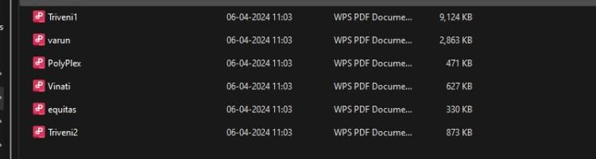

The data sources are in the form of pdf . The data source contains:

1. Name of the Director.

2. Director type : Independent / executive

3. DIN

The dataset consists of PDFs containing vital details about company directors: their full names, roles (Independent/Executive), and Director Identification Numbers (DINs). "Name of the Director" refers to their complete name, "Director Type" categorizes them as Independent or Executive, and DIN is a unique identifier issued by the Ministry of Corporate Affairs, India.

**4.2 Text Extraction Methodology**:

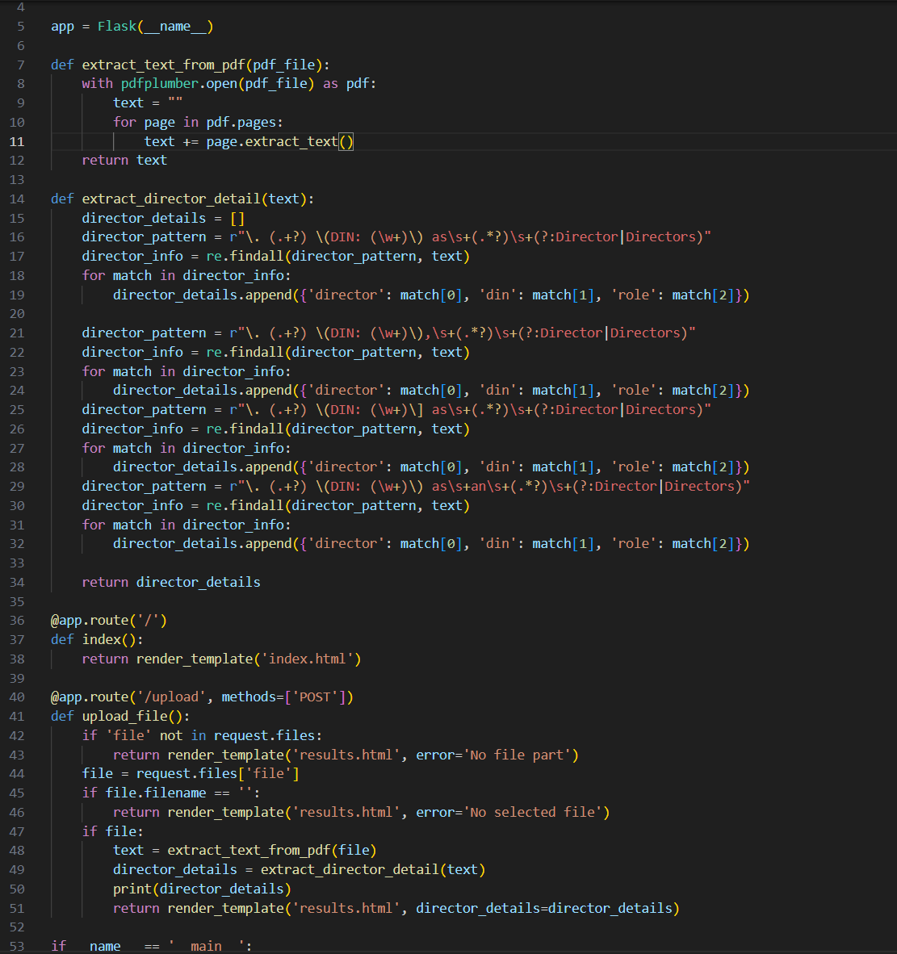

This Flask application provides a simple web interface for uploading PDF files and extracting information about directors from them. When a user uploads a PDF file through the web interface, the upload_file function is triggered. It first checks if a file was uploaded, then extracts the text from the PDF using pdfplumber. The extracted text is then passed to the extract_director_detail function, which searches for director details using regular expressions. The extracted director details are then displayed on a results page rendered using a Jinja2 template.

The extract_director_detail function defines several regular expressions to capture different patterns of director details, such as name, DIN, and role. It iterates through each pattern, finds all matches in the text, and constructs a list of dictionaries containing the director's name, DIN, and role. Finally, the Flask application runs on the local server, allowing users to access it through a web browser, upload PDF files, and view the extracted director details.

**5. Final Implementation**

For the final implementation, a web application is developed using Flask, leveraging libraries such as re, spacy, PyPDF2, pdfplumber, and various NLP and ML techniques. The defined patterns for retrieving 'Director Name', 'DIN', and 'status' are:

director_pattern = r"\. (.+?) \(DIN: (\w+)\) as\s+(.*?)\s+(?:Director|Directors)":

This pattern captures the name, DIN, and role of a director from a text string.

It searches for a pattern where the name is followed by "(DIN: XXXX)" and "as" followed by the role, where XXXX is the DIN number.

The name is captured using (.+?), the DIN number using (\w+), and the role using (.*?). The (?:Director|Directors) at the end allows for flexibility in matching the role.

director_pattern = r"\. (.+?) \(DIN: (\w+)\),\s+(.*?)\s+(?:Director|Directors)":

This pattern handles a variation where there's a comma after the DIN number.

It captures the name, DIN, and role similarly to the previous pattern, but accounts for the presence of a comma after the DIN number.

director_pattern = r"\. (.+?) \(DIN: (\w+)\] as\s+(.*?)\s+(?:Director|Directors)":

This pattern handles a variation where there's a closing square bracket "]" after the DIN number instead of a parenthesis.

It captures the name, DIN, and role in a similar manner to the first pattern, but accommodates the different format of the DIN specification.

director_pattern = r"\. (.+?) \(DIN: (\w+)\) as\s+an\s+(.*?)\s+(?:Director|Directors)":

This pattern handles a variation where there's the word "an" before the role

1.Launch the web app by executing the Python code, which will deploy the application on localhost.

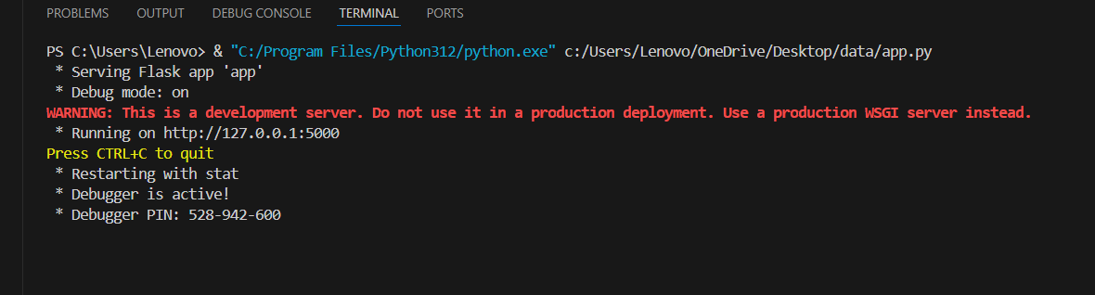

2.Access the deployed web application through a browser. Upon successful deployment, the webpage will be displayed as intended.

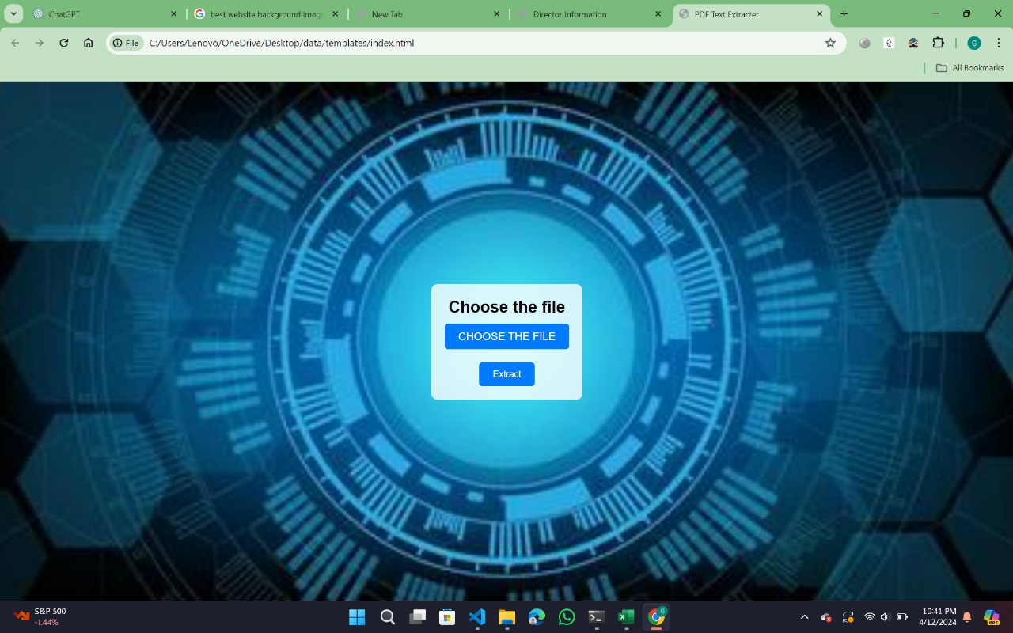

3.Please upload the PDF document in the designated PDF upload section and Proceed by clicking the upload button.

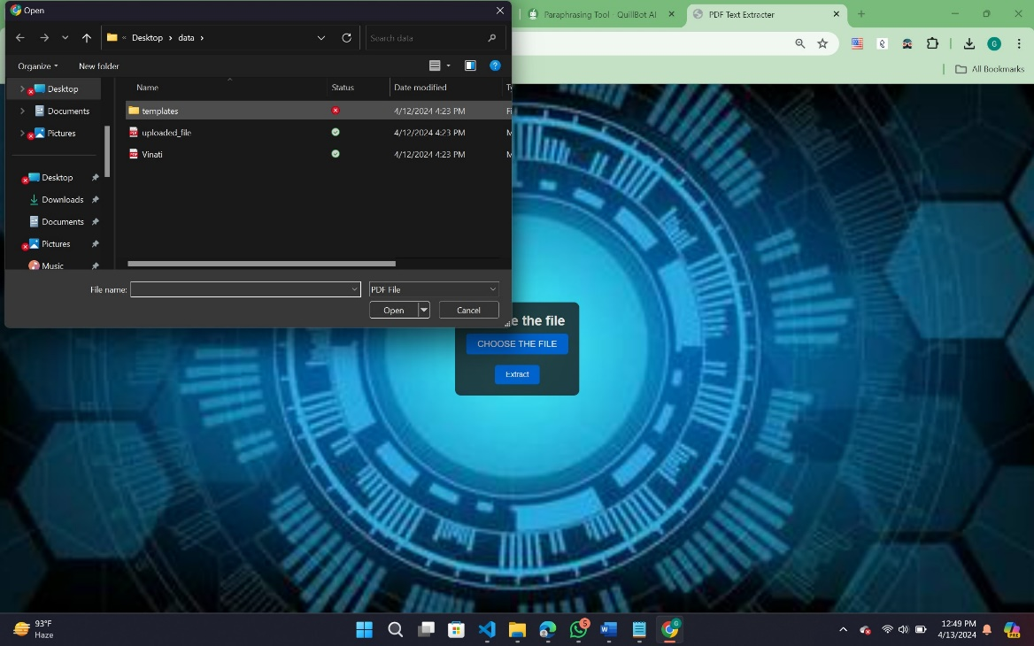

4. You will find the results on the 'Director Details Page'.

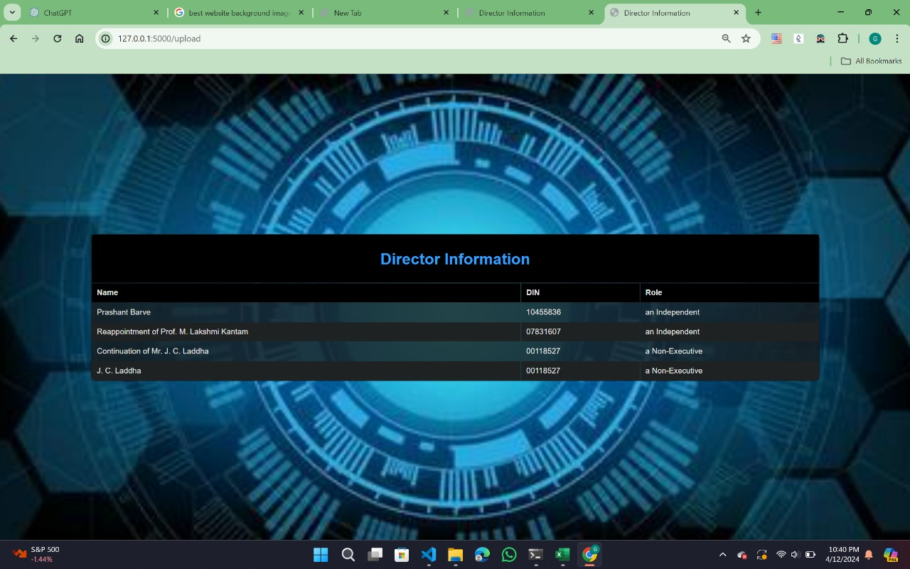

**6. Conclusion**

In conclusion, our capstone project effectively demonstrated the usefulness of using machine learning for PDF data extraction. Through this endeavor, we have proved its capacity to expedite procedures, increase data quality, and improve document accessibility for a diverse variety of stakeholders. This validation highlights the potential benefits of using machine learning techniques into multiple areas to improve efficiency and effectiveness in information extraction operations.

Finally, the Flask application described offers a user-friendly online interface for retrieving information about directors from uploaded PDF files. Using the pdfplumber library for PDF text extraction and regular expressions for pattern matching, the program quickly pulls director information such as name, DIN (Director Identification Number), and role from a variety of textual forms inside PDF documents. The application's user-friendly interface simplifies the process of acquiring and evaluating director information, allowing enterprises, legal organizations, and regulatory compliance to make more informed decisions.

**Future Scope**

The project could be expanded to incorporate advanced natural language processing (NLP) techniques for extracting director details more accurately, handling variations in text formatting, and identifying additional relevant information such as tenure and appointment terms. Integration with OCR (Optical Character Recognition) technology could enable the extraction of director details from scanned PDFs and images, broadening the scope of document sources compatible with the application. Implementing a database backend would facilitate storing and querying extracted director information, enabling users to manage and analyze data across multiple PDF files. Adding support for multiple file formats beyond PDF, such as Word documents and scanned images, would enhance the versatility and usability of the application, catering to a wider range of document sources. Lastly, incorporating user authentication and access control mechanisms would enhance security and privacy, enabling the application to be deployed in environments requiring restricted access to sensitive information.